Name : Aarya Tiwari

Roll no. 16010421119

Batch : B2

**Aggregate Pipelining**

**Data :**

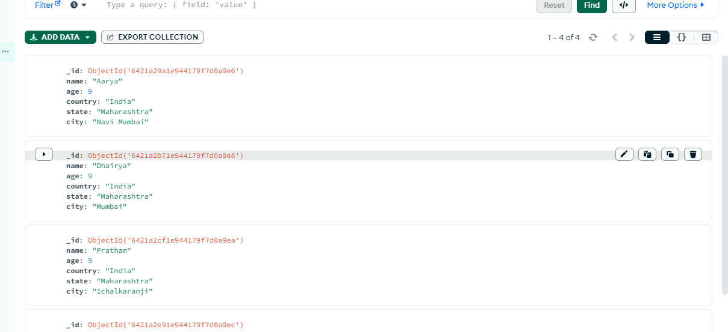

1. $match

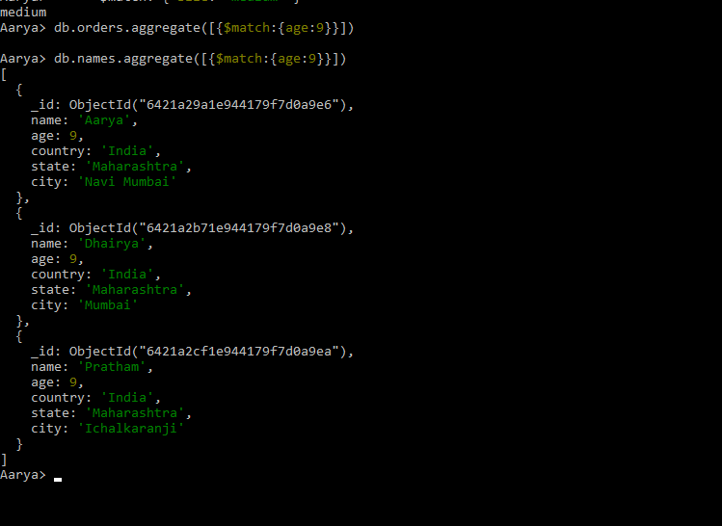

1. $group

